1. Ashwani Bhatia is Managing Director of which bank who has been appointed as whole-time member (WTM) of the Securities and Exchange Board of India (SEBI)?
A. Bank of Baroda B. Union Bank of India
C. Punjab National Bank D. State Bank of India
Ans. D
Sol. * The cabinet has appointed Ashwani Bhatia, managing director (MD) of the State Bank of India (SBI), as a whole-time member (WTM) of the Securities and Exchange Board of India (SEBI).
* According to some sources, the Appointments Committee of the Cabinet (ACC) has also approved Ashwani Bhatia’s appointment as a whole-time member of SEBI for three years from the date of his assumption of the command.
2. Who among the following has won the International Association of Working Women Award recently?
A. Deepika Padukone B. Sushmita Sen
C. Priyanka Chopra D. Aishwarya Rai
Ans. B
Sol. • Bollywood actress Sushmita Sen has won the International Association of Working Women Award for 'Aarya 2'.
• She has been awarded for an outstanding performance by a female actor in a TV series for her show 'Aarya 2'.
• The award is presented by the DC South Asian Film Festival (DCSAFF).
3. Recently, an international team of researchers has discovered a new species of rain frog which is named after __________.
A. Vandana Shiva B. Wangari Maathai
C. Great Thunberg D. Medha Patkar
Ans. C
Sol. • An international team of researchers has discovered a novel species of rain frog and named it after Swedish environmental activist Great Thunberg.
• The new species of the frog is named Pristimantis gretathunburgae.
• The Pristimantis gretathunburgae was found by the team on an island in eastern Panama called Cerro Chucanti.
• The team, which discovered the new species, was led by Abel Batista from Panama and Konrad Mebert from Switzerland.
4. Atal Innovation Mission (AIM), NITI Aayog has announced its partnership with which company to drive Augmented Reality (AR) skilling among the Indian youth?
A. Snap B. Canon
C. Nikon D. Sony
Ans. A
Sol. • Atal Innovation Mission (AIM), NITI Aayog has announced its partnership with Snap Inc. to drive Augmented Reality (AR) skilling among the Indian youth.
• The partnership is initially for 2 years and is expected to train over 12,000 teachers affiliated with Atal Tinkering Labs on Augmented Reality, enabling the reach of the program to millions of students affiliated with ATL’s network of schools.
• Snap Inc also announced its partnership with Atal Incubation Centers (AICs).
5. The Ministry for Fisheries has been rolled out ‘Sagar Parikrama’ initiative in which state in first phase aimed at understanding “challenges, experiences and aspirations of fishermen community?
A. Maharshtra B. Gujarat
C. Goa D. Tamil Nadu
Ans. B
Sol. * Union Minister of Fisheries, Animal Husbandry and Dairy Parshottam Rupala outlined that the “Sagar Parikrama” initiative will be aimed at understanding “challenges, experiences and aspirations of fishermen community”, look at the scope of seafood exports, as well as to popularise schemes that the fishing community in coastal areas can avail of.
6. Which one the following was not built by Shahjahan?
A. Taj Mahal B. Red Fort of Delhi
C. Jama Masjid of Delji D. Buland Darwaja
Ans. D
Sol. Buland Darwaja was built in 1576 A.D. by Akbar to commemorate his victory over Gujarat. It is the main entrance to the palace at Fatehpur Sikri, a town which is 43 km from Agra, India. Buland Darwaza is the highest gateway in the world and is an example of Mughal architecture. It displays Akbar's empire.
7. Sardar Sarovar Dam is constructed on which of the following river?
A. Tapti B. Mahanadi
C. Sabarmati D. Narmada
Ans. D
Sol. Sardar Sarovar Dam is located in Nevagam(Gujarat). It is Constructed on Narmada River. Gujarat, Rajasthan, MP and Maharashtra get water and electricity from this Dam. Its Foundation Stone was laid out by Pt. Jawahar Lal Nehru on 5 april, 1961.
8. The lightning and thunder are the characteristic features of
A. Troposphere B. Stratosphere
C. Mesosphere D. Ionosphere
Ans. A
Sol. The troposphere is the lowest layer of Earth's atmosphere. The troposphere starts at Earth's surface and goes up to a height of 7 to 20 km (4 to 12 miles, or 23,000 to 65,000 feet) above sea level. Most of the mass (about 75-80%) of the atmosphere is in the troposphere. Almost all weather occurs within this layer.
9. All are the effects of LSD except:
A. Hallucination B. High blood pressure
C. Dilated pupils D. Kidney failure
Ans. D
Sol. LSD(lysergic acid diethylamide) is an extremely hallucinogen drug which is synthetically made by lysergic acid. This acid is found in ergot, fungus that grows on rye and other grains.
10. GhiyasuddinTughlaq founded Tughlaq Dynasty in 1320. His real name was ____.
A. Ghazi Malik B. Abu'l-Fath Khan
C. Jauna Khan D. Ghazi Khan
Ans. A
Sol. • Ghiyasuddin Tughlaq founded Tughlaq Dynasty in 1320. His real name was Ghazi Malik.
• His father was Turkish, and mother was a Hindu.
• After the death of Ghiyasuddin Tughlaq his son Jauna (Ulugh Khan) succeeded him under the title Mohammad-bin-Tughlaq, in 1325.
11. A, B and C can finish a job working alone in 72, 24 and 36 days respectively. In how many days they can finish the job if they worked together?
A. 12 B. 9
C. 15 D. 18
Ans. A
Sol. Working efficiency of A =
Working efficiency of B =
Working efficiency of C =
Combine efficiency of A, B and C = 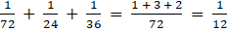
So number of days required = 12
12. A rectangular plot having its length and breadth in the ratio 5: 2 and area 360 m² is to be paved with tiles in the shaded portions all of same dimensions. Cost of 1 tile is Rs.105 and dimensions of 1 tile is 25 cm×20 cm. If the cost of pavement is Rs.200 per m² then find the total cost incurred in pavement of the plot.
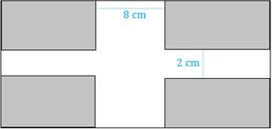
A. Rs. 506600 B. Rs. 506500
C. Rs. 506000 D. Rs. 566000
Ans. C
Sol.
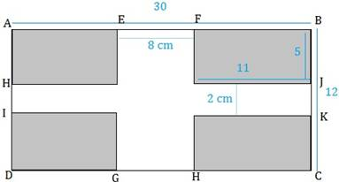
Let the length of plot be ‘l’ and width be ‘b’
Then, l: b = 5: 2
⇒ l = 5b/2
Area = lb= 360 m²
⇒ 5b²/2 = 360
⇒ b= 12 m
⇒ ∴ l= 30 m
The area to paved = 4× Area of one shaded rectangle
⇒ AE = (30 – 8)/2= 11 m
⇒ AH= (12 – 2)/2 = 5 m
Area of one shaded portion= 11× 5 =55 m²
Total area to be paved = 4× 55 = 220 m²
⇒ Area of 1 tile = (0.25 × 0.2) m²= 0.05 m²
∴ No. of Tiles required = 220/0.05 = 4400 tiles
⇒ Cost of Tiles = 4400× 105 = Rs.462000 ⇒ Cost of Pavement =220× 200 = Rs.44000
∴ Total Cost = 462000+44000 = Rs. 506000
13. The distance between two vertical poles is 60 m. The height of one of the poles is double the height of the other. The angles of elevation of the top of the poles from the middle point of the line segment joining their feet are complementary to each other. The heights of the poles are:
A. 10 m and 20 m B. 20 m and 40 m
C. 20.9 m and 41.8 m D. m and m
Ans. D
Sol. BE = DE = 30 metre
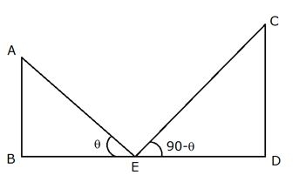
From
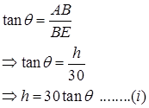
From CDE,
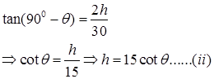
By multiplying both equations,
h² = 30×15×tanθ×cotθ
h² = 30×15
h =15√2 metre
and
2h = 30√2 metre
14. Amit can complete a work in 25 days and Punit can complete the same work in 20 days. Punit alone worked at it for 10 days and then left the work. In how many days will Amit alone complete the remaining work?
A. 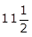 B. 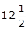
C. 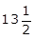 D. 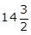
Ans. B
Sol. Amit complete the work in 25 days
Amit one day efficiency =
Punit one day efficiency =
Work done by punit in 10 days = 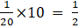
Remaining work = 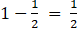
Amit will complete the remaining work in = 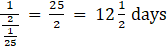
15. In a mixture of 90 L the ratio of milk and water is 2 : 1. If the ratio of the milk and water is to be 1 : 2, then the amount of water to be further added is
A. 90 L B. 85 L
C. 80 L D. 55 L
Ans. A
Sol. Ratio of milk and water in mixture of 90 L = 2 : 1
Quantity of water = 30 L
Quantity of milk = 60 L
If the ratio of milk and water is to be 1 : 2, then In 60 L of milk, water should be 120 L
Quantity of water to be added = 90 L
16. A milkman buys milk at Rs 25 per litre and adds 1/4 of water to it and sells the mixture at Rs 26 per litre. His gain (in %) is?
A. 25 B. 20
C. 30 D. 15
Ans. C
Sol. Let the milk purchase be 4 litre.
Then, water added =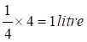
Total cost price of mixture = 4 × 25+1× 0 = 100
Selling price of mixture = 5 × 26=130
So, profit percentage = 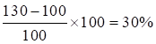
17. If the income tax is increased by 12.5%, net income is decreased by 2.5%, then find the rate of income tax?
A. 20% B. 15%
C. 16.67% D. 10%
Ans. C
Sol. Rate of income tax = {(decreased%)/(increased% + decreased %)} x 100
After putting the values in this logic {2.5/(12.5+2.5)} x 100,
Answer will be 16.67%
18. Find the largest 4 digit number which when divided by 9 leaves remainder 5, when divided by 10 leaves remainder 6 and when divided by 12 leaves remainder 8.
A. 9900 B. 9896
C. 9000 D. 9889
Ans. B
Sol. LCM of 9, 10 and 12 is 180
On dividing 9999 by 180 we get remainder 99
So 9999-99 = 9900 is exactly divisible by 180 or 9, 10 and 12.
Difference between dividends and remainders is constant i.e.
9 – 5 = 10 – 6 = 12 – 8 = 4
Therefore if we subtract 4 from 9900 it must fulfill all conditions.
So, 9900 – 4 = 9896 is the required number.
19. A bank pays simple interest at 5% per annum on the first Rs. 8000 and an interest of 12% for amounts above that. Find the interest earned by Gaurav if he deposits Rs. 20,000 with the bank for 2 years.
A. 3580 B. 3525
C. 3680 D. 3625
Ans. C
Sol. Total money invested = Rs.20,000
A bank pays simple interest at 5% per annum on the first Rs. 8000 and an interest of 12% for amounts above that.
Hence, Interest earned by Gaurav
= 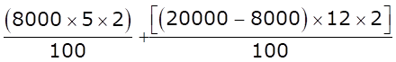
= Rs. (800+2880) = Rs. 3680
20. A boat goes a certain distance at 40 km/hr and comes back the same distance at 24 km/hr. What is the average speed (in km/hr) for the total journey?
A. 32 B. 28
C. 34 D. 30
Ans. D
Sol. let the distance be D km
Average speed = Total distance/Total Time = 2D / (D/24 + D/40)
= 240/8
= 30 km/hr
21. In the following question, some statements followed by some conclusions are given. Taking the given statements to be true even if they seem to be at variance from commonly known facts, read all the conclusions and then decide which of the given conclusions logically follows the given statements.
Statement:
Vocational education is the education that trains people to work in various jobs such as technician, trade, and craft. It refers to the career and technical education that allows students to get ready for a specific career.
Conclusion:
I. Students get a real working environment during vocational programs.
II. Employability of the graduates in India has become a major concern. Only a few of the graduates from all streams are considered to have employable skills, indicating the need for high-quality vocational education to train the youth for Jobs.
A. If only conclusion I follows B. If only conclusion II follows
C. If both I and II conclusion follow D. If neither I nor II conclusion follows
Ans. A
Sol. Conclusion I follows. As vocational education will provide tremendous opportunities for youth in various sectors. It will help build a skilled and educated workforce that is the need of the hour.
Conclusion II does not follow. It represents the correct scenario of the current situation but it is not a conclusion of the given statement.
Hence, option A is correct answer.
22. If Smriti is the daughter of the wife of the only son of the father of Payal’s father. How is Smriti related to Payal, if Smriti’s grand-father has no grandson?
A. Sister B. Cousin
C. Sister-in-law D. Mother
Ans. A
Sol.
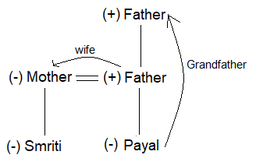
According to the above diagram;
Father of Payal’s father means Grandfather of Payal.
Smriti is the daughter of the wife of Payal’s Grandfather’s only son, i.e. father of Payal.
Therefore, Smriti is the sister of Payal.
Hence, option A is the correct response.
23. Arrange the following words as per order in the dictionary
1) Pearl
2) Peasant
3) Pea
4) Peanut
A. 3, 1, 4, 2 B. 3, 4, 1, 2
C. 1, 3, 2, 4 D. 1, 2, 3, 4
Ans. B
Sol. It is clear that, the correct order is:
3. Pea 4. Peanut 1. Pearl 2. Peasant
Hence, the correct order is B.
24. If a mirror is placed on the line AB, then which of the answer figures is the right image of the given figure?
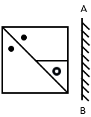
A. 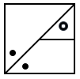 B. 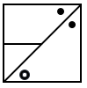
C. 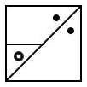 D. 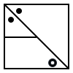
Ans. C
Sol. The mirror image for the given figure is,
Hence, option C is the correct answer.
25. If ‘MAY’ is written as ‘NZB’, ‘JUNE’ is written as ‘QFMV', So how will ‘GENIUS’ will be written in that language?
A. TVMRFH B. TVNSFH
C. TWMRFH D. UVMRHF
Ans. A
Sol. M is opposite letter to N
A is opposite letter to Z
Y is opposite letter to B
Similarly,
J is opposite letter to Q
U is opposite letter to F
N is opposite letter to M
E is opposite letter to V
Similarly, GENIUS is written as TVMRFH
So, the correct answer is option A.
26. In an examination, Raj got more marks than Mukesh but not as many as Priya. Priya got more marks than Gaurav and Kavita. Gaurav got less marks than Mukesh but his marks are not the lowest in the group. Who is second in the descending order of marks?
A. Priya B. Kavita
C. Raj D. None of these
Ans. C
Sol. According to the given question,
Priya > Raj > Mukesh > Gaurav > Kavita
Hence, option C is the correct answer.
27. Direction: Which one of the given responses would be a meaningful order of the following in ascending order?
1. Sending 2. Encoding
3. Receiving 4. Decoding
A. 1,2,3,4 B. 2,1,3,4
C. 2,4,3,1 D. 4,2,1,3
Ans. B
Sol. Meaningful order of the words in ascending order:
2. Encoding
1.Sending
3. Receiving
4. Decoding
Thus the correct sequence is 2, 1, 3, 4
Hence Option B is the correct answer.
28. A series is given with one term missing. Select the correct alternative from the given ones that will complete the series.
Display, Ideal, Indian, Study, Brands, ?
A. Jurisdiction B. Found
C. Adsorbed D. Handshake
Ans. A
Sol. Here,
Display → ‘D’ is at first position.
Ideal → ‘D’ is at second position.
Indian → ‘D’ is at third position.
Study → ‘D’ is at fourth position.
Brands → ‘D’ is at fifth position.
So in next word ‘D’ has to be at sixth position.
Thus the next word in the series is ‘Jurisdiction’.
Hence, option A is the correct answer.
29. A migrating bird flies 40 km North, then turns East and flies 50 km, then turns North and flies 110 km, and turns to its left and flies 50 km. Where is it now with reference to its starting position?
A. 150 km South B. 150 km North
C. 70 km North D. 70 km South
Ans. B
Sol.
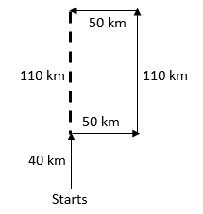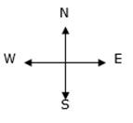
Thus with reference to its starting position the bird is now 110 + 40 = 150 km towards north.
Hence, option B is the correct answer.
30. In the following question, select the odd word from the given alternatives.
A. Ring B. Tyre
C. Plate D. Bangle
Ans. C
Sol. Except for plate all the examples of circular hollow rings.
Hence, option C is the correct response.
31. Which of the following is a self complementing code?
A. 8421 code B. excess 3 code
C. pure binary code D. gray code
Ans. B
Sol. Excess-3 code is self complementing code i.e. the 9’s complement of the decimal number is easily obtained by changing 1’s to 0’s and 0’s to 1’s
32. ‘Dead Zone’ is defined as
A. Initial warm up time of an instrument
B. largest change in Input quantity, for which there is no instrument output
C. Respond time of an instrument
D. Unmeasured instrument reading beyond instrument maximum range
Ans. B
Sol. Dead zone is defined as the largest change in the physical variable to which instrument does not respond.
33. Which motor is generally used for railway traction purpose now a days?
A. DC series motors B. 3 – ϕ Induction motor
C. DC shunt motors D. Synchronous motors
Ans. B
Sol. Earlier DC series motors were used but these days 3 – ϕ Induction motors are used because of excellent torque slip characteristics and easy speed control.
34. Full scale o/p voltage of n-bit DAC is
A. (2^{n} – 1) B. 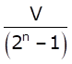
C. (2^{n} – 1) × resolution D. 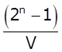
Ans. C
Sol. Full scale o/p = (2^{n} – 1) × resolution.
35. Find the KVL equation for the following circuit.
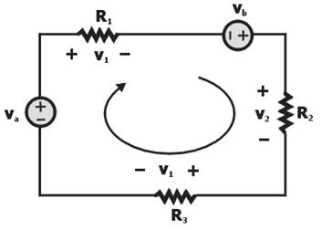
A. v_{a} + v_{b} = i(R₁- R₂ + R₃) B. v_{a} + v_{b} = i(R₁ + R₂ – R₃)
C. v_{a} – v_{b} = i(R₁ + R₂ – R₃) D. v_{a} + v_{b} = i(R₁ + R₂ + R₃)
Ans. D
Sol. By applying KVL we have
V_{a} – iR_{i} + V_{b} – iR₂ – iR₃ = 0
∴ V_{a} + V_{b} = i(R₁ + R₂ +R₃)
36. Among the following characteristic, which statement is incorrect for the tunnel diode.
A. It has large forward voltage drop B. dynamic conductance is negative
C. excellent conductor in reverse direction D. Thickness of the Barrier is very small
Ans. A
Sol. When the concentration of impurity is increased to 1 part in 10³, the characteristic of p-n junction diode changes significantly & this p-n junction diode is called tunnel diode.
Characteristic of Tunnel diode:
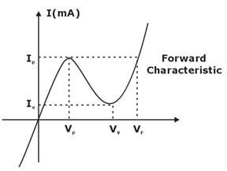
1. Impurity concentration is high.
2. Depletion width ≈ 100 Å
3. Barrier thickness very small
4. Excellent conductor in Reverse direction
5. Thickness of Barrier is about 1/5 of visible light
37. According to maximum power transfer theorem, maximum power transfer occurs when
A. Load R is equal to the half the R of network
B. Load R is equal to twice the r of network
C. load R is equal to the R of network looking back at it from voltage terminal
D. Load r is equal to the R of network looking back at it from load terminals with all sources being replaced by their respective internal resistance
Ans. D
Sol. Maximum power transfer theorem states that the load will be supplied with maximum power if the load resistance is equal to the thevenin's equivalent resistance/norton's equivalent resistance. Maximum power transfer theorem doesn't relate anything with efficiency, but is concentrated with maximum power transfer from source to load.
38. Hand tool application uses which of the following motors?
A. AC series motor B. Shaded pole motor
C. Resistance motor D. None of the above
Ans. A
Sol. For hand tool applications, AC series motor is used.
So, Option (A) is correct.
39. Which one of the following heating method is most inefficient method of electrical heating?
A. Infrared Heating B. Resistance Heating
C. Dielectric Heating D. Induction Heating
Ans. A
Sol. Infrared Heating is the most inefficient method of electric heating. It is also the simplest form of electric heating. Here the electromagnetic radiation coming out from an incandescent light bulb is focused to the surface to be heated. It is mostly used for drying out the wed painted surface of an object.
40. Stability of a system is not affected by________.
A. reactance of line B. losses
C. reactance of generator D. output torque
Ans. B
Sol. The seven essential factors affecting the stability are broadly classified into two parts
1) Mechanical factors:
1) Prime mover input torque
2) The inertia of prime mover and generator
3) The Inertia of motor and shaft load
4) Shaft load output torque
2) Electrical factors:
1) Internal voltages of the synchronous generator
2) The reactance of the system including the generator, line, and motor etc.
3) Internal voltage of the synchronous motor
41. Buchholtz relay is operated by
A. eddy currents B. gas pressure
C. electromagnetic induction D. electrostatic induction
Ans. B
Sol. Buchholz relay is operated by gas pressure. Buchholz relay is used for protection against internal faults.
42. Which one of the following statements is not correct for electrodynamometer type instrument?
A. It can measure a range of currents and voltages up to 10A and 600 V respectively.
B. The deflecting torque is inversely proportional to the square of the current.
C. It can be used for both a.c. and d.c. systems.
D. It has the same calibration for d.c. instruments as well as a.c. measurements.
Ans. B
Sol.
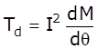
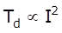
Deflecting torque is directly proportional to the square of the current.
Hence, option B is incorrect.
43. Swinburne’s Test is related to
A. Transformer B. Induction Machine
C. Synchronous Machine D. DC Machine
Ans. D
Sol. Swinburne's test is the most commonly used and simplest method of testing of shunt and compound wound DC machines which have constant flux. In this test the efficiency of the machine at any load is pre-determined. We can run the machine as a motor or as a generator.
44. If a function is given as f = AB + 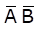 then find its dual.
A. 0 B. 1
C. D. AB
Ans. C
Sol. Given function f = AB + 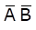
For dual function
x +
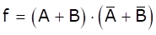
Dual of f =
45. While making the choice of drive, which of the following factors is NOT considered?
A. Speed of driving and driven machines B. Cost
C. Drive machine temperature D. Space available
Ans. C
Sol. Following factors is considered while making the choice of drive.
(1) Nature of electric supply
(2) Capital and running cost
(3) Maintenance cost
(4) Available space
(5) Nature of load
(6) Size, rating and duty cycle of motors
(7) Starting condition of load
(8) Electric motor and its characteristics
46. A number is expressed in binary two’s complement as 10011. Its decimal equivalent value is
A. 19 B. 13
C. –19 D. –13
Ans. D
Sol.
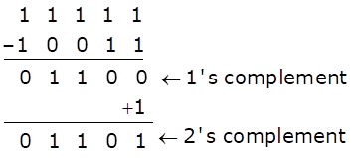
(11101)₂ = (13)₁₀
Therefore, the decimal equivalent value = (–13)₁₀
47. In case of Hunting, when there is super synchronous speed, Damper Bar develops
A. Reactance torque B. Induction motor torque
C. Eddy current torque D. Induction generator torque
Ans. D
Sol. In case of rotor speed larger than synchronous speed, induction generator torque is developed in the opposite direction of rotor rotation. In this case rotor decelerate to reach synchronous speed.
48. The number of KVL & KCL equations in a circuit having 5 nodes & 8 branches.
A. 4, 3 B. 3, 4
C. 4, 4 D. 3, 3
Ans. C
Sol. N = 5, b = 8
The number of KVL equations
= (b – n +1)
= 8 – 5 + 1
= 4
The number of KCL equations
= (n – 1)
= 5 – 1
= 4
49. In a 3-phase circuit, reactive power is measured using wattmeter. It is observed that wattmeter reading is zero for line voltage = 400V and line current = 15 Amp.
Power factor of the load is______.
A. 1 B. 0
C. 0.707 D. 0.86
Ans. A
Sol. For three phase circuits
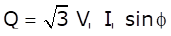
Given, Q = 0
So, 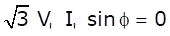
or
or = PF
50. A ripple count with n flipflop can function as ________
A. n : 1 B. n/2 : 1
C. 2n : 1 D. 2^{n} : 1
Ans. D
Sol. For one output, the flip flop has two possibilities each and hence for n flip flops the possible counts are 2^{n} : 1.
51. The principle of operation of hot wire instrument is
A. magnetic effect B. chemical effect
C. electric effect D. thermal effect
Ans. D
Sol. ⇒ Hotwire instrument work on the principle of the thermal effect, that the length of wire increases because of the heating effect due to the current flow through it.
⇒ When the current passed through the fine platinum iridium wire it gets heated up & expands.
⇒ Used for both AC & DC current.

52. As per the given below circuit diagram, which one of the following diode is in conducting mode?
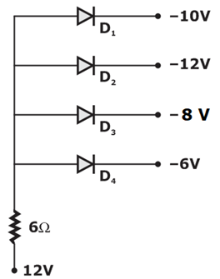
A. D₁ B. D₂
C. D₃ D. D₄
Ans. B
Sol. In Common Anode Configuration, the diode which has lowest voltage on its cathode will be in conducting mode therefore as per the circuit diagram diode D₂ will Conduct.
53. In Fig., if we neglect I_{CBO} (being small), then the value of I_{C} is…………..
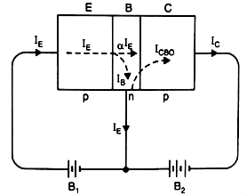
A. α I_{E} B. β I_{B}
C. I_{B} D. I_{E}
Ans. A
Sol. The value of I_{c}=α I_{E}+I_{CBO} if I_{CBO} is neglected.
Then I_{c}=α I_{E}
54. Bulk resistance of a diode is
A. The sum of half the resistance value of n-type and p-type material
B. The sum of resistance value of n-type and p-type material
C. Equivalent resistance of the resistance value of p-type and n-type material is parallel
D. None of the above
Ans. B
Sol. Bulk resistance is offered by the diode in forward region above the barrier voltage and is the sum of the resistance value of p-type and n-type semiconductor materials.
55. The voltage drop is the main consideration while designing a
A. feeder B. service mains
C. distributor D. none of the above
Ans. C
Sol. In the design of a distributor, the voltage drop is the main consideration. It is because for the proper operation of appliances, it is desirable that variations in voltage at the consumer’s terminals should be within of the rated voltage.
56. If the below figure defines the property of Voltage Follower, then what will be the values of Resistance R_{g} & R_{f} respectively:
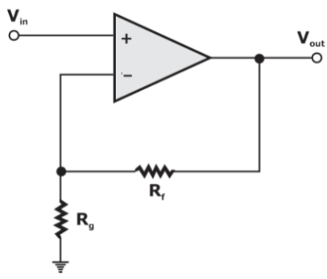
A. R_{g} = ∞ B. R_{g} = 0
C. R_{f} = ∞ D. None of the above
Ans. A
Sol. For the resistive feedback Op-Amp Feedback gain is defined as β = R_{g} / (R_{g} + R_{f}) = 1/ (1+ [R_{f}/R_{g}]).
Now if R_{g} tends to infinity and for any value of R_{f}, then its results Feedback gain β = 1, which is the required condition for voltage follower model.
Therefore the above circuit model reduces to,
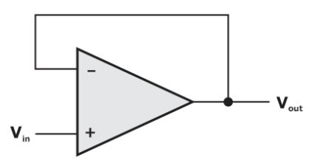
57. A half-wave rectifier type a.c. voltmeter is with a 20 V rms signal What is the equivalent d.c. output voltage?
A. 6.4 V B. 9 V
C. 12.8 V D. 18 V
Ans. B
Sol. D.C. output voltage from a half-wave rectifier = 0.45 x V_{rms}
= 0.45 x 20 = 9 V
58. Electrical instruments which measure electrical quantity in form of mechanical deflection is called –
A. Primary instrument B. Secondary instrument
C. Integrating instrument D. recording instrument
Ans. B
Sol. Secondary instrument ⇒ Instruments which measure electrical quantity in form of mechanical deflection are called secondary instrument, they convert electrical energy into mechanical energy. the mechanical deflection shows reading
Ex - PMMC, MI, EDM, type instruments etc.
59. Which of following statement is correct with respect to series R-L-C circuit at Resonance?
A. bandwidth is the ratio of quality factor to resonance frequency.
B. quality factor = 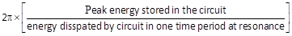
C. At resonance circuit behaves as current rejector circuit
D. None of the above
Ans. B
Sol. Since
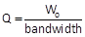
Bandwidth =
Also
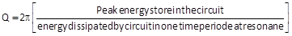
and at resonance the impedance in the circuit is lowest. So the current is maximum in series R-L-C circuit at resonance.
So, it acts as current magnifier circuit
60. Resistance switching is normally employed in
A. bulk oil breakers B. minimum oil breakers
C. air blast circuit breakers D. all of A, B and C
Ans. C
Sol. In air blast circuit breaker Resistance switching is employed.
61. Electric current may be defined as
A. Rate of transfer of electric charge B. Velocity of charge
C. Capacity to store charge D. Charging of battery
Ans. A
Sol. Electric current is defined as heat of transfer of electric charge
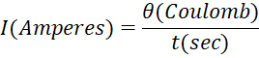
62. In a amplifier, the phase difference between voltage across collector load and signal voltage is………………
A. 180º B. 270º
C. 90º D. 0º
Ans. D
Sol. In a amplifier, no phase difference occurs between voltage across collector load and signal voltage.
63. In Bipolar Junction transistors, the type of configuration which will give both voltage gain and current gain is:
A. CB B. CE
C. CC D. None of the options
Ans. B
Sol. Bipolar Transistor is a three terminal device, there are basically three possible ways to connect it within an electronic circuit with one terminal being common to both the input and output.
CB has voltage gain but no current gain.
CE has both current and voltage gain.
CC has current gain but no voltage gain.
64. Which one of the following is not a self-generating type of transducer?
A. Bourdon gauge for the measurement of pressure
B. Pitot tube for the measurement of fluid flow velocity
C. Thermistor for the measurement of temperature
D. Photovoltaic cell
Ans. C
Sol. Self-Generating type of transducer:
1. Bourdon gauge
2. Pitot tube
3. Photovoltaic cell
65. For the commutated d.c. machine stator, it has riveted poles and the ends of the poles are called
A. pole shoe B. pole face
C. pole arc D. pole gap
Ans. A
Sol. For the commutated DC machine stator, it has riveted poles and the ends of the pole am called pole shoe.
66. In a Three phase system, the volt ampere rating is given by?
A. V_{ph} I_{ph} B. 3 V_{L} I_{L}
C. V_{L} I_{L} D. V_{L} I_{L}
Ans. D
Sol. VA for single phase =
VA for 3 phase system =
67. Which of the following cores have linear characteristics?
A. Steel core B. CRGO core
C. Air core D. None of the above
Ans. C
Sol. Air cores have linear magnetization characteristics i.e., they do not saturate whereas steel core and CRGO core have non-linear magnetization characteristics.
68. For proper operation of a transistor, its collector should have
A. Proper forward bias B. Proper reverse bias
C. Very small size D. None of these
Ans. B
Sol. For the proper operation of the transistor, its collector terminal must be properly reversed biased.
69. Which of the following heating methods has leading power factor?
A. Resistance B. Induction
C. Dielectric D. Both B and C
Ans. C
Sol. • Resistances heating method has unity PF.
• Induction heating method has lagging PF.
• Dielectric heating method has leading PF.
70. A line of 50 km length and 100 Hz frequency is considered as:
A. Long line B. Small line
C. Medium line D. None of above
Ans. C
Sol. For nature of line l × f criteria is used.
L × f < 4000 {small line}
4000 < l × f <10,000 {Medium line}
L × f > 10,000 {long line}
Here l × f = 50 × 100 = 5000 hence it is a medium line.
71. Which of the following statements is / are correct with regard to three phase induction motor?
1) In cascading of two induction motor speed control technique, one induction motor must be squirrel cage while the other can be either slip ring or squirrel cage motor.
2) By increasing rotor resistance, starting torque and maximum torque increases.
3) Pole changing speed control technique can be used only in squirrel cage induction motor.
4) Cogging and crawling phenomenon are usually not encountered in slip ring induction motor
A. 1, 2 and 4 B. 3 and 4
C. 2 and 3 D. 1, 3 and 4
Ans. B
Sol. In cascading of two induction motor speed control technique, one induction motor must be slip ring type while the other can be either slip ring or squirrel cage motor.
By increasing rotor resistance, starting torque increases but maximum torque remains unchanged.
Pole changing speed control technique can be used only in squirrel cage induction motor.
Cogging and crawling phenomenon are usually not encountered in slip ring induction motor as their starting torque is high enough to accelerate it.
72. Which one of the following is not a reason, for a semiconductor silicon (Si) to be preferred over Germanium (Ge)?
A. Higher temperature stability
B. Higher band gap
C. Higher leakage current
D. Higher breakdown voltage
Ans. C
Sol. The elemental semiconductor Silicon (Si) is preferred over Germanium (Ge) for the following reasons:
1. Higher temperature stability
2. Higher band gap
3. Lower leakage current
4. Higher breakdown voltage
5. Easy fabrication process
73. In a single phase transformer which of the following is correct
1. maximum voltage regulation is Z_{pu} & occurs at lagging power factor
2. minimum voltage regulation is R_{pu} & occurs at lagging power factor
3. zero voltage regulation is obtain at leading power factor
A. 1 only B. 1, 3 only
C. 1 and 2 only D. 1, 2 and 3 only
Ans. B
Sol. Voltage regulation in 1-ϕ transformer
V.R = R_{pu} cos ϕ ± x_{pu} sin ϕ
where R_{pu} = p.u. resistance
x_{pu} = pu reactance
ϕ = power factor angle
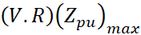 occurs at lagging pf at 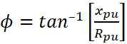
(V.R) zero occurs at leading pf at 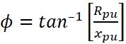
(V.R) min occurs at leading pf at ϕ = 90°
(V.R) min = – x_{pu}
74. An alternator is supplying a load of 300 KW at a power factor of 0.6 lagging. If the power factor is raised to unity, how many more kw can alternator supply for the same KVA loading?
A. 150 KW B. 200 KW
C. 300 KW D. 100 KW
Ans. B
Sol.
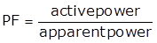
So, from question
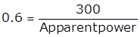
Apparent power=500 kVA.
At unity power factor, Active power = Apparent power.
So active power=500kW. So, you will get an additional 200kw at UPF.
75. Which of the following statements is / are correct.
1. Q-meter works based on series RLC circuit.
2. Anderson bridge is used to measure low quality factor
3. Load current in current transformer is primary current
A. 1 and 2 only B. 2 only
C. 2 and 3 only D. 1, 2 and 3
Ans. D
Sol. Q-meter works based on series RLC circuit.
For low quality factor (Q < 1), Anderson bridge is used.
Primary current in current transformer is load current while on secondary side, instrument is placed.
76. In a 3ϕ induction motor, rotor is rotating at speed of N_{r}(rpm), stator flux is rotating at speed of N_{s}(rpm), then speed of stator flux with respect to rotor is
A. N_{s} B. N_{s} – N_{r}
C. N_{s} + N_{r} D. N_{r}
Ans. B
Sol. Given, rotor speed (N_{r}) rpm
Stator flux speed N_{s} (rpm)
Speed of stator flux w.r.t rotor is N_{s}–N_{r}
Note: Speed of stator flux & rotor flux is same w.r.t. stator body.
77. The percentage limiting error, in the case of an instrument reading of 20 A with a 0 to 100 A ammeter having a guaranteed accuracy of 1% full-scale reading is
A. 5% B. 10%
C. 20% D. 15%
Ans. A
Sol. % Limiting error 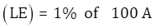= 1 A
Percentage limiting error for 20A is 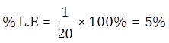
78. Steel poles are generally used for transmission lines because
A) it has more mechanical strength and more life.
B) it occupies less space and give better appearance.
C) It has high cost.
Which of the above provided reason/s is/are correct.
A. Only A B. Only B
C. Only C D. Both A and B
Ans. D
Sol. Steel poles possess greater mechanical strength, longer life and permit longer spans to be used. Such poles are generally used for distribution purposes in the cities. This type of supports need to be galvanised or painted in order to prolong its life.
79. In a lossy dielectric material, the ratio of conduction current density to placement current density is given as-
A. 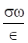 B. 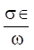
C. 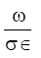 D. 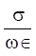
Ans. D
Sol. Conduction current density J_{c} = σ E
Displacement current density 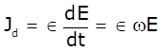
The ratio of conduction current density and displacement current density in the medium.
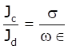
80. Bundled conductors in EHV transmission system provide:
A. Increased corona loss B. Increased line reactance
C. Reduced line capacitance D. Reduced voltage gradient
Ans. D
Sol. For transmission of more power for long distances to load centers Extra High Voltage (EHV) transmission is employed. Implementing Extra High Voltage has advantage of reduction in the copper losses and improves efficiency. However transmission of voltage beyond 300kV will poses some problems such as Corona effect which causes significant power loss and interference with communication circuits if round single conductor per phase is used. In order to reduce corona effect hollow round conductors are used. Keeping economical constraints other option is instead of using hallow round conductor it is preferable to use more than one conductor per phase which is called Bundled Conductors. For transmission of power beyond 400kV bundled conductors are employed.
Advantages of Bundled Conductors:
Bundled conductors are primarily employed to reduce the corona loss and radio interference. However they have several advantages:
• Bundled conductors per phase reduce the voltage gradient in the vicinity of the line. Thus reduces the possibility of the corona discharge. (Corona effect will be observed when the air medium present between the phases charged up and start to ionize and acts as a conducting medium. This is avoided by employing bundled conductors)
• Improvement in the transmission efficiency as loss due to corona effect is countered.
• Bundled conductor lines will have higher capacitance to neutral in comparison with single lines. Thus they will have higher charging currents which help in improving the power factor.
• Bundled conductor lines will have higher capacitance and lower inductance than ordinary lines they will have higher Surge Impedance Loading (Z=(L/C)^{1/2}). Higher Surge Impedance Loading (SIL) will have higher maximum power transfer ability.
• With increase in self GMD or GMR inductance per phase will be reduced compared to single conductor line. These results in lesser reactance per phase compared to ordinary single line. Hence lesser loss due to reactance drop.
81. In __________ drive each machine is driven by its own separate motor with the help of gears and pulley
A. Individual drive B. Multi motor drive
C. Group Drive D. None of the above
Ans. A
Sol. Individual drive. In “individual drive”, each machine is driven by its own separate motor with the help of gears, pulley etc.
Examples: Single-spindle drilling machines, various types of electrical hand tools and simple types of metal working machine tools and mechanisms.
For driving heavy machines such as for lifts, cranes, shapers, lathes etc. and for the purposes where constancy of speed and ﬂexibility of control is required, such as in paper mills and textile industry, the individual drive is essential.
82. Which one of the given fuse is bigger __________?
A. DC B. AC
C. DC or AC D. AC and DC are same
Ans. A
Sol. Always DC resistance is less than A.C resistance i.e. R_{AC} = 1.6 R_{DC}
i.e. I_{DC} is more than I_{AC}
∴ so, DC fuse rating more than that of AC fuse rating.
83. The torque generated in the aluminium disc of induction type energy meter is maximum when the phase difference between the magnetic fields of shunt and series electromagnets is equal to
A. 180° B. 90°
C. 45° D. 0°
Ans. B
Sol. For energy meter
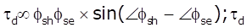 is maximum when 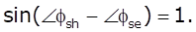So angle between 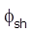 and 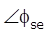 should be 90°.
(b) option is correct.
84. Which of the following statement is/are correct about transformer?
1) Core type transformer require more amount of copper as compared to shell type transformer
2) Size of distribution transformer is smaller as compared to similar power transformer
3) Auto transformer has lower p.u impedance as compared to two winding transformer
4) Shell type transformer is suitable for low voltage and low power applications.
A. 1, 2 and 3 B. 1, 2 and 4
C. 1, 3 and 4 D. 1, 2, 3 and 4
Ans. C
Sol. Core type transformer:
- Require more amount of copper.
- Suitable for low flux density application.
- It requires less amount of insulation. So, it is suitable for high voltage and high power applications.
Shell type transformer:
- Suitable for low voltage and low power applications.
Auto transformer has higher efficiency, lower p.u. impedance and lower voltage regulation as compared to 2-winding transformer.
Size of distribution transformer is larger as compared to similar power transformer as iron to copper ratio of distribution transformer is higher.
85. The slope of B-H curve of a material gives its
A. absolute permeability B. relative permeability
C. retentivity D. none of the above
Ans. A
Sol. The slope of B-H curve of a material gives absolute permeability.
86. In a J-K master-solve flip-flop.
A. master is clocked when the clock is low
B. solve is clocked when the clock is high
C. master is clocked when the clock is low and solve is clocked when the clock is high
D. master is clocked when the clock is high and solve is clocked when the clock is low.
Ans. D
Sol. Master is clocked when the clock is high and solve is clocked when the clock is low for the JK master slave.
87. If current and potential coils of a wattmeter are interchanged, then after energizing circuit
A. Current coil damaged only
B. Potential coil danged only
C. Both current and potential coils are damaged.
D. None of the above
Ans. A
Sol. Current coil connect in series with load and it has low resistance
Potential coil connect in parallel across supply and it has High resistance
So, due to interchanged, current coil connected across supply due to low resistance, high current flows through current coil and gets damaged.
88. The permissible voltage drop from supply terminal to any point on the wiring system should not exceed?
A. 4% + 1 volt B. 2% + 1 volt
C. 1% + 1 volt D. 3% + 1 volt
Ans. D
Sol. Voltage Drop - The purpose of the National Electrical Code (NEC) is to help safeguard persons and property from electrical hazards. Although it does not generally consider voltage drop a safety issue, it contains six Fine Print Notes (FPNs) that recommend you size circuit conductors large enough to provide reasonable efficiency of equipment. The permissible voltage drop from supply terminal to any point on the wiring system is 3%+1V.
89. CRO cannot measure _______directly
A. Voltage B. Current
C. Frequency D. Phase difference
Ans. B
Sol. For a CRO, voltage is applied to the vertical and Horizontal plates. So, in order to measure current, first voltage is converted into current. Also, CRO can measure phase difference using Lissajous pattern whereas directly using waveform frequency can be measured.
90. for steady state current inductor acts as?
A. Voltage source B. Open circuit
C. Short circuit D. Current source
Ans. C
Sol.
Therefore, at steady state voltage there is no current. So, for steady state voltage capacitor acts as a open circuit.
91. What is the value of time constant In RL series circuit R=2Ω and L=2mH?
A. 1 msec B. 2 msec
C. 4 msec D. 100 sec
Ans. A
Sol.
92. What is the maximum span upto which the wooden poles can be used?
A. 20 m B. 50 m
C. 60 m D. 100 m
Ans. C
Sol. Wooden poles:
- These are made of seasoned wood (sal or chir) and are suitable for lines of the moderate X-sectional area and of relatively shorter spans, say up to 60 meters
- Such supports are cheap, easily available, provide insulating properties and, therefore, are widely used for distribution purposes in rural areas as an economic proposition
- They have a comparatively smaller life (20-25 years) and cannot be used for voltages higher than 20 kV
- They have less mechanical strength and require periodical inspection
Steel Poles:
- They are used for system voltages up to 33 kV in low and high-voltage distribution systems
- When compared to wooden poles steel poles have advantages like lightweight, long life, and greater strength
- These are used for a longer span, i.e., from 50 to 80 m
- These are costlier than wooden and RCC poles
- All steel supports should be well-galvanized and have a life of at least 30 years
Concrete poles (RCC Poles):
- Reinforced concrete poles have become very popular as line supports in recent years.
- They have greater mechanical strength, longer life, and permit longer spans than steel poles.
- Moreover, they give a good outlook, require little maintenance, and have good insulating properties.
- The maximum permissible span for RCC poles is 80 - 100 meters.
- The main difficulty with the use of these types of electric poles is the high cost of transport owing to their heavyweight
93. Which of the following statement are correct for Hysteresis motor?
1) At synchronous speed eddy current torque is zero.
2) rotor is a smooth solid cylinder of hard steal
3) Hysteresis torque is constant at all speeds.
A. 1, 2 B. 2, 3
C. 1, 3 D. 1, 2, 3
Ans. D
Sol. Eddy current losses P_{e} 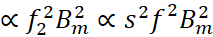
Air gap power P_{g} =
Torque T =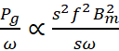
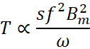
At synchronous speed s = 0
So, eddy current torque is also zero
Similarly
Hysteresis loss P_{h} 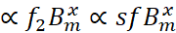
Air gap power P_{g} =
Torque T =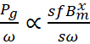
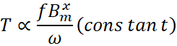
Also, the rotor of hysteresis motor is made of hard steel
So, all statements are correct
94. A three-stack, 6 pole stepper motor has 8 teeth on the rotor as well as on stator. What is the step size?
A. 15° B. 20°
C. 10° D. 7.5°
Ans. A
Sol. Given:
No. of rotor teeth N_{r} = 8,
No. of stack m = 3
Step size = 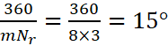
95. Consider the circuit shown in figure below, the output of the circuit is
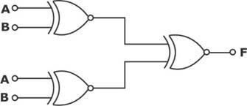
A. 0 B. 1
C. D.
Ans. B
Sol.
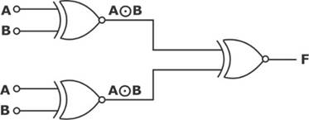
Input of X-NOR Gate is same and same input generate logic high at the output.
96. Determine Thevenin Equivalent circuit parameters for the given circuit.
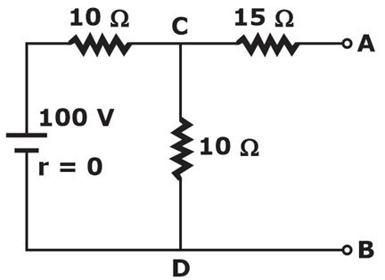
A. V_{Th} = 25 V, R_{Th} = 20 Ω. B. V_{Th} = 50 V, R_{Th} = 25 Ω.
C. V_{Th} = 50 V, R_{Th} = 20 Ω. D. V_{Th} = 100 V, R_{Th} = 20 Ω.
Ans. C
Sol. Finding RTh: By replacing all the sources present in the network with their internal impedances, the given circuit reduces to as shown below and further performs series and parallel resistors operations to reduce the circuit.
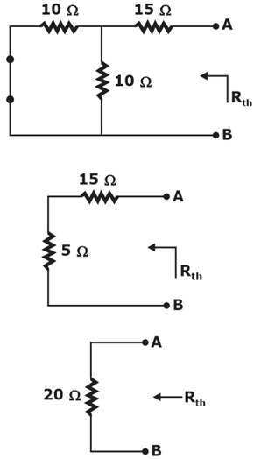
R_{Th} = 20 Ω
Finding V_{Th}:
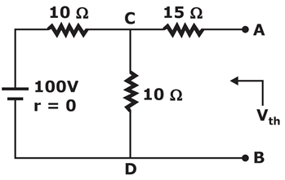
Since the 15 Ω resistor is open-circuited no current will flow through it and the voltage across the terminals AB is the same as that of the voltage across the terminals CD it can calculate by using the voltage division rule as shown as:
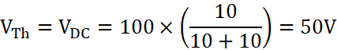
Therefore, Thevenin’s equivalent circuit is given as:
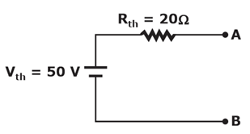
97. Consider the following statements.
1). EMMC measures both AC and DC current and voltage.
2). EMMC type Ammeter consists 2 fixed coils.
3). In EMMC, spring provides controlling torque.
Which of the above statements is/are correct?
A. 1 and 2 B. 2 and 3
C. 1 and 3 D. 1, 2 and 3
Ans. D
Sol. * EMMC type voltmeter and ammeter measures both AC and DC voltage and current respectively.
* EMMC type ammeter consisting of 2 fixed coil.
* For small load currents both connected in series and for large current, both connected in parallel without need of shunt resistance.
* Spring provides controlling torque.
98. Choose the correct statement rotated to interpole windings of a DC generator.
S1: It is connected in series with main field winding.
S2: It is connected in Parallel with the armature winding.
A. S1 only B. S2 only
C. Both S1 and S2 D. Neither S1 nor S2
Ans. D
Sol. In a DC machine generator or motor interpole windings are connected in series with the armature winding. Its purpose is to create a pole of same polarity as the main pole ahead (in case of DC generator) and behind (in case of DC motor) in the direction of rotation.
99. To supply peak load of a power station, …………….. power plant is very suitable.
A. thermal B. nuclear
C. diesel D. none of the above
Ans. C
Sol. Peak load power stations deliver power for brief intervals in a day. Such stations must be put in service very quickly. Consequently, they are equipped with prime movers such as diesel engines and gas turbines that can be started up in a few minutes. It may be mentioned here that thermal power stations take from 4 to 8 hours to start up while nuclear stations may take several days.
100. In generating mode, an induction machine operates as a generator with a shaft speed which is greater than the synchronous speed, if the slip is
A. zero B. unity
C. greater than unity D. less than zero
Ans. D
Sol. Induction motor works as generator when it runs at speed greater than synchronous speed. In other words, it should have negative slip.
Torque speed characteristics of 3-phase IM:
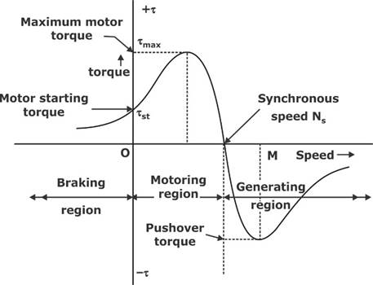
Hence, if N > N_{s}, then s < 0.
101. A 3 mA is converted into 0 – 300 mA having 99 Ω internal resistance. The value of shunt resistance will be:
A. 1 Ω B. 5 Ω
C. 3 Ω D. 2 Ω
Ans. A
Sol. Multiplying factor
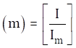
⇒ where I = 300 mA, I_{m} = 3 mA
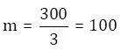
⇒ 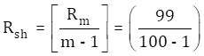⇒ R_{sh} = 1 Ω
102. There are additional losses that arise from the non-uniform current distribution in the conductors and the core losses generated in the iron due to the distortion of the magnetic flux distribution from the load currents. Such losses are known as
A. steel losses B. frictional losses
C. stray load losses D. windage losses
Ans. C
Sol. Stray losses are additional loses that arises due to non-uniform current distribution if produce heat in the core. In conductor, the stray load loss is due to the circulating currents set-up by the alternating leakage flux produced by the load current in the conductors. These circulating or eddy currents make the conductor current distribution non uniform and as a result the effective resistance of the conductor current distribution non uniform and as a result the effective resistance of the conductor increases. Because of this, extra ohmic or I²R loss is produced which is called stray load loss.
103. In case of a squirrel-cage induction motor using three-phase bridge inverter, which one of the following statements is correct for speed control?
A. If frequency increases, then starting torque decreases with constant supply voltage.
B. If frequency increases, then starting torque increases with constant supply voltage.
C. If frequency decreases, then starting torque decreases with constant supply voltage.
D. If frequency decreases, then starting torque increases with constant supply voltage.
Ans. A
Sol. For 3-phase IM, torque equation
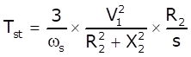
At starting R₂ ≪ X₂
Hence,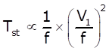
If V₁ constant.
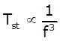
If frequency increases, starting torque decreases.
104. Which one of the following has the least number of free electrons in ¡t?
A. Conductors B. Semiconductors
C. Superconductors D. Insulators
Ans. D
Sol. The electrons in conduction band are called free electrons.
At room temperature, Conductors have maximum free electrons due to which they easily conduct electricity as they have overlapped Valence band and Conduction band.
Semiconductors have forbidden energy gap (<2eV) between valence band and Conduction band but at room temperature, the electrons in valence band gain sufficient energy (>2eV) to undergo transition to conduction band, but number of electrons is less compared to that of conductors.
Superconductors don’t exhibit superconductivity at room temperature , so they mainly behave as conductors.
Insulators have large forbidden energy gap (>13eV) between conduction band and valence band. At room temperature, the electrons in valence band can’t attain sufficient energy to transit to the conduction band. So free electrons are least in Insulators.
105. The maximum value of mutual inductance of two inductively coupled coils with self inductance of and is?
A. B.
C. D.
Ans. B
Sol. Mutual inductance of two inductively coupled coils is given by:
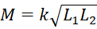
For maximum value;
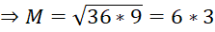
106. If in a common emitter amplifier, base current I_{B} is 0.1 mA and collector current I_{C} is 5 mA. Then the value of current gain in common base amplifier will be:
A. 50 B. 51
C. 0.02 D. 0.98
Ans. D
Sol. Current gain in CE amplifier, 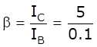 = 50
Current gain in CB amplifier will be:
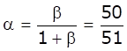
Current gain in CB amplifier = 0.98
107. The given figure is of which type of MOSFET?
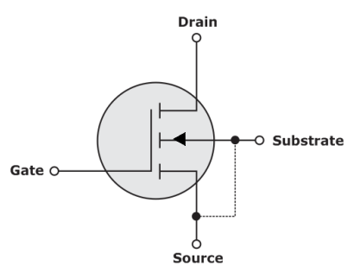
A. N-Channel Enhancement Type B. P-Channel Enhancement Type
C. N-Channel Depletion Type D. P-Channel Depletion Type
Ans. A
Sol. The above model is of N-Channel Enhancement Type. In N-Channel Enhancement type MOSFET as much V_{GS} greater than V_{t}, the channel formed for the conduction of Field Effect Transistor is more enhanced hence it is called as enhancement type.
108. Choose the correct statement (S) related to strain gauge
(1) In stain gauge the basic principle is change of resistance with strain
(2) As compared to semiconductor strain gauge, metal strain gauge has large gauge factor
A. 1 only B. 2 only
C. 1 and 2 both D. Neither 1 Nor 2
Ans. A
Sol. Basic principle of strain gauge is change of resistance with strain. So, statement (1) is correct.
Gauge factor of metal strain gauge = 2 to 10
Gauge factor of semiconductor strain gauge = – 200 to 200.
So, statement (2) is incorrect
109. If the induction motor drive is capable of bidirectional power flow where limited range of speed control is required for large power applications, then this arrangement is called
A. Static conductance drive B. Static Scherbius drive
C. Static compressive drive D. Static reluctance drive
Ans. B
Sol. Power can flow from source to load and vice-versa, when induction motor is operated static Scherbius drive.
110. In which of the following instructions, no flags are affected?
1) STAX
2) DCR
3) CMA
4) CMC
A. 1 and 4 B. 2 and 3
C. 1 and 3 D. 2 and 4
Ans. C
Sol. STAX : Store accumulator indirect
DCR : Decrement source by 1
CMA : Complement accumulator
CMC : Complement carry
In STAX and CMA instruction, no flags are affected.
In DCR operation, except carry, all flags are affected.
In CMC instruction, the carry flag is modified, no other flags are affected.

111. In a round rotor alternator, reactive power is maximum at a load angle of,
A. 90° B. 180°
C. 0° D. 45°
Ans. C
Sol.
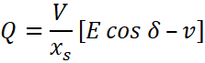
For 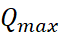
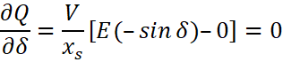
But δ ≤ 90° for stability
So, δ = 0°
112. Which of the following properties is correct about servomotor.
A. High inertia and high starting torque B. low inertia and low starting torque
C. low inertia and high string torque D. High inertia and low starting torque
Ans. C
Sol. Properties of servomotors
⇒ Low inertia and high starting torque
⇒ Due to low-inertia they are able to reverse direction quickly
⇒ They are able to accelerate and de-accelerate quickly.
⇒ They are able to return to a given position time after time without and drift.
113. In a transformer, ____harmonic is rich in magnetic inrush.
A. 1st B. 2nd
C. 5th D. 7th
Ans. B
Sol. In a transformer, 2nd harmonic is rich in magnetic inrush. Inrush currents are typically rich in harmonics, the second harmonic in particular. Therefore, the second-harmonic content in the differential currents has been traditionally used in transformer differential elements to block or to increase restraint during inrush conditions.
114. with the positive probe on a NPN base, an ohmmeter reading between the other transistor terminals should be?
A. High resistance B. Open
C. Low resistance D. Infinite
Ans. C
Sol. In a bipolar transistor, each "PN" junction is essentially a diode. Consequently, you can use a multimeter to test each pair of pins of the device (with the third pin left floating in each test) to determine the location and orientation of each diode. Not surprisingly, this task is simplified if you have a "diode test" function on your multimeter. Regardless, it is relatively easy to find the "base" of the transistor, but disambiguating which of the two other pins is the collector or the emitter is more difficult. Still, it's possible.
115. Economizers improve boiler efficiency by
A. 1 to 5% B. 4 to 10%
C. 10 to 12% D. 12 to 14%
Ans. B
Sol. Economizers generally improve the boiler efficiency by 4 to 10 %
116. The donor type of impurity is
A. phosphorous B. aluminium
C. Calcium D. iron
Ans. A
Sol. Donor type impurity belongs to 5TH group. They have five electrons in their outer shell.
5TH group have elements - phosphorus, arsenic, bismuth etc.
117. If the magnetic core has a constant permeability by making air as media for a coil current and the resultant flux. linkage, then
A. the energy and co-energy are equal B. the energy is greater than the co-energy
C. the energy is less than the co-energy D. the co-energy is not developed
Ans. A
Sol. Core has constant permeability (air as media)
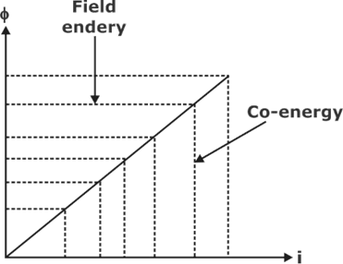
So, result flux ∝ current
Field energy = Co-energy
118. A cycloconverter-fed induction motor drive is most suitable for which one of the following?
A. Compressor drive B. Machine tool drive
C. Paper mill drive D. Cement mill drive
Ans. B
Sol. Cyclo-convertor is suitable where precise control required (means not for cement & compressor drive). In paper mill constant speed/smoothly variable speed is required.
So, it can be used to drive machine tool drive.
119. Magnetic field intensity at the center of a circular current loop is,
A. Proportional to radius of the loop.
B. Inversely proportional to the radius of the loop
C. Inversely proportional to the square of the radius of the loop.
D. None of the above
Ans. B
Sol. The Field at the center of circular wire carrying a current of I is-
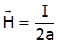
where a is the radius of circular wire.
120. IE Rule 35 is related with?
A. Danger Notices B. Accessibility of bare conductors
C. Earth terminal on consumer’s premier D. Supply to vehicles, cranes
Ans. A
Sol.




