**POWER PLANT ENGINEERING**

**1. RANKINE CYCLE**

ηR = =

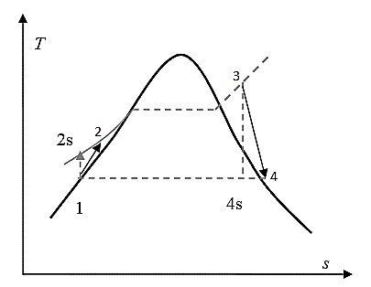

Isentropic efficiency of pump($η_{pump}$)= $\frac{Isentropic work}{Actual work}$ = $\frac{h_{2s-}h_{1}}{h_{2-}h_{1}}$

Isentropic efficiency of turbine($η_{turbine}$)= $\frac{Actual work}{Isentropic work}$ = $\frac{h_{3-}h_{4}}{h_{3-}h_{4s}}$

**1.1. METHODS OF INCREASING THE EFFICIENCY OF RANKINE CYCLE**

$$η∝1-\frac{T_{L}}{T_{H}}$$

**1.1.1. Decreasing the of Condenser Pressure**

* Mean temperature of heat rejection in the condenser decreases. Thus, the thermal efficiency of the cycle will be increased.

**1.1.2. Superheating the Steam to High Temperature**

* Superheating the steam will increase the network output and the efficiency of the cycle. It also decreases the moisture contents of the steam at the turbine exit.

**1.1.3. Increasing the Boiler Pressure**

* Mean temperature of heat addition increases hence thermal efficiency increases.

**1.2. IDEAL REHEAT RANKINE CYCLE**

* To take advantage of the increased efficiencies at higher boiler pressure without facing the excessive moisture content at final stages of the turbine, reheating is used.

Heat input= Primary heat+Reheat= $(h_{3}$- $h_{2}$)+ $(h_{5}$- $h_{4}$)

Wturbine= WH-P turbine+ WL-P turbine= -)+-)

**1.3. IDEAL REGENERATIVE RANKINE CYCLE**

* The mean temperature of heat addition can also be increased if heat addition at low temperature is avoided such that feed water enters the boiler at saturated liquid condition. The feed water can be brought to saturated condition by internal heating using extracted steam. This concept is known as regeneration.

y = amount of bleed from turbine

Qin= h5-h4

Qout= (1-y) (h7-h1)

Wturbine out= (h5-h6) +(1-y) (h6-h7)

Wpump=(1-y) Wpump1+ Wpump2

Wpump1= v1(P2-P1) and Wpump2= v3(P4-P3)

v is specific volume at pump inlets

**2. GAS TURBINE ENGINE**

**2.1. Brayton Cycle**

1-

==

**2.1.1. Maximum Pressure Ratio**

* (rP)max =
* At maximum pressure ratio the efficiency of brayton cycle is equal to Carnot cycle operating between same temperature limit.
* At maximum pressure ratio the net work is zero.

**2.1.2. Optimum Pressure Ratio**

* (rP)opt= =
* Optimum pressure ratio gives maximum network.

**2.1.3. Actual Brayton Cycle**

Isentropic efficiency of compressor($η_{compressor}$)= $\frac{Isentropic work}{Actual work}$ = $\frac{h_{2s-}h_{1}}{h_{2a-}h_{1}}$

Isentropic efficiency of turbine($η_{turbine}$)= $\frac{Actual work}{Isentropic work}$ = $\frac{h_{3-}h_{4a}}{h_{3-}h_{4s}}$

**2.1.4. Work ratio**

Work ratio (rw)=

**2.1.5. Back Work ratio**

Back work ratio( rbw)=

* Back Work Ratio for gas power cycles:40% - 60%
* Back Work Ratio for vapor power cycles: 1% - 2%

**2.1.6. Specific Power**

* Specific power = $\frac{Net Work}{3600}$ kWh/kg

**2.1.7. Brayton Cycle with Reheat**

**2.1.8. Brayton Cycle with Intercooling**

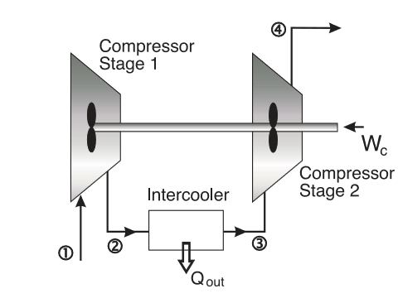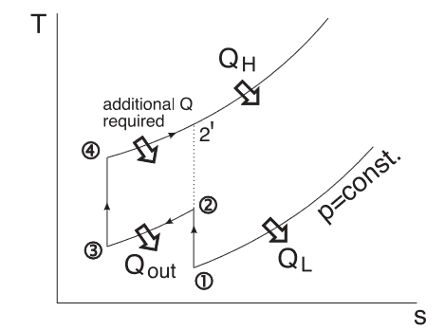

* For perfect intercooling T3 =T1
* The optimum pressure ratio per stage in case of n stage compression with intercooling



**2.1.9. Brayton Cycle with Regeneration**

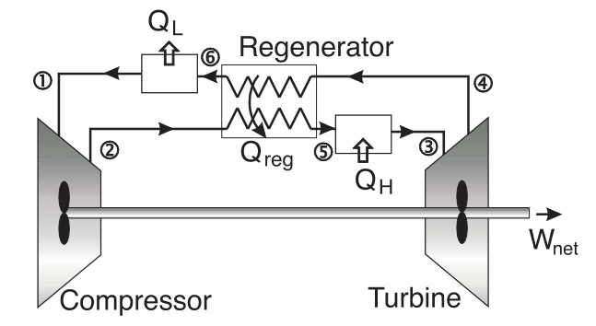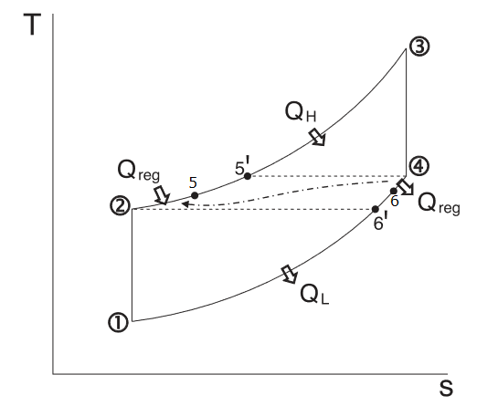

*Qregen,*actual *=* h5 – h2

*Qregen,*max *=* h5’ – h2 = h4 – h2

= =

**3. POWER PLANT COMPONENTS**

**3.1 Characteristics of fire tube and water tube boilers:**

|  |  |  |
| --- | --- | --- |
| **Characteristics** | **Fire tube boiler** | **Water tube boiler** |
| Steam Pressure | It is limited to 20-30 bar. In case of waste heat boilers, it can be more. | It is virtually unlimited within metallurgical and design limits. |
| Unit output | Limited to about 20 MW. Within design limits. | It is virtually unlimited. |
| Fuel | All commercial fuels and treated waste can be used. | Any fuel can be used. Also, the furnace size is large. |
| Erection | It is package ready for work site. | It is to be shop assembled or erected at site. |
| Efficiency | Normally 80-85% gross calorific value but can be further increased using accessories. | Normally 8-90%. Gross calorific but can be further increased using accessories. |
| Application | Generally, for heat supply. | Generally, for power and heat supply together. |
| Inspection requirement | Frequent inspection requirement. It is more than in water tube. | Inspection requirement is less than in fire tube boiler, boilers. |

**3.2 BOILER MOUNTINGS AND ACCESSORIES**

• A boiler other than heat supplying unit, shell and tubes, several other devices are used for its control, safe and efficient operation.

• Devices which are mounted on boiler for ***its control and safe operation are called “mountings”*** while ***devices which are mounted on boiler for improving its performance are called “accessories”.*** Thus, boiler mountings are necessary while boiler accessories are optional.

**3.3 CIRCULATION**

• The flow of water and steam within the boiler circuit is called circulation.

• Adequate circulation must be provided to carry away the heat from the furnace.

• If circulation is caused ***by density difference, the boiler is said to have natural circulation.***

• If it is caused ***by a pump, it has forced*** or controlled circulation.

• There is a term called “circulation ratio” (CR) used in this connection. It is defined as:

Circulation ratio = 

A boiler drum is said to be ***“priming” if there is too much moisture carry-over because of a high-water level or a high steaming rate***. Erratic feedwater control and rapid changes in steaming rate can induce priming.

Another phenomenon encountered in the delivery of impure steam is foaming. ***Foaming is a condition resulting from the formation of bubbles on the water surface.*** It is caused by the presence of saponification agents in the boiler water, like oil, certain dissolved salts and high alkalinity.

**3.4 BOILER DRAUGHT**

• Draught refers to the pressure difference created for the flow of gases inside the boiler.

• Boiler unit has a requirement of the expulsion of combustion products and supply of fresh air inside furnace for continuous combustion. The obnoxious gases formed during combustion should be discharged at such a height as will render the gases unobjectionable. Draught may be created naturally or artificially by using some external device. Draught can be classified as below:

(a). In this the pressure difference is created naturally without using any positive displacement device.

(b). Artificial draught is created using some external assistance causing forced displacement of gases. It can be created either by using mechanical devices or steam. Artificial draught can be of induced type, forced type or combination of two types.

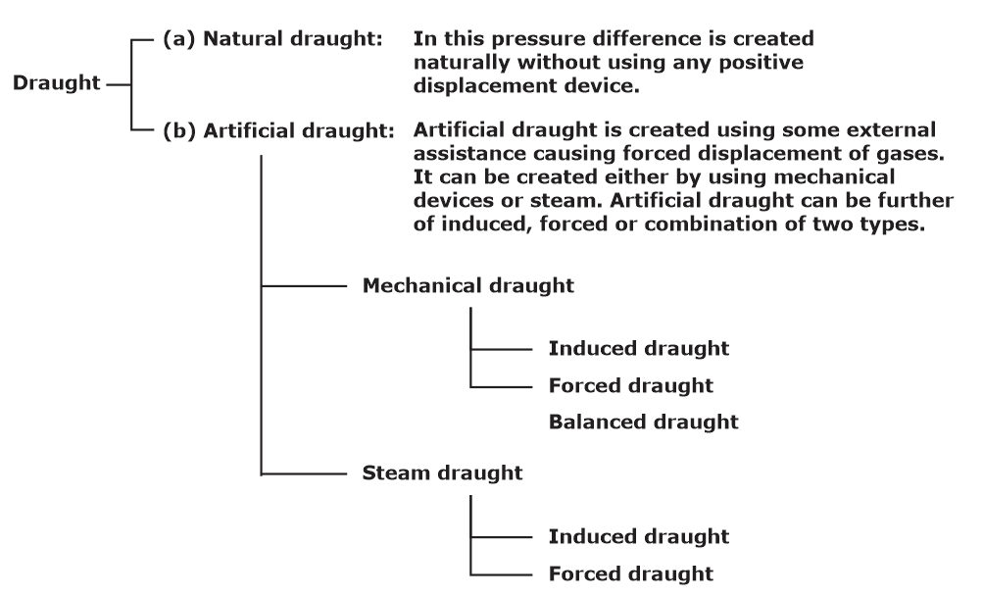

**3.5** **EQUIVALENT EVAPORATION**

* For comparing one boiler with other any of the above parameters cannot be considered as they are interdependent. Therefore, for comparing the capacity of boilers working at different pressures, temperatures, different final steam conditions etc. a parameter called “equivalent evaporation” can be used.



**4. AIR COMPRESSOR**

* Compressor is a device which is used to compress the gas or vapour from lower to higher pressure and for that work input is required from outside.

**4.1. Reciprocating compressor**

**4.1.1. Work input required (without clearance volume)**

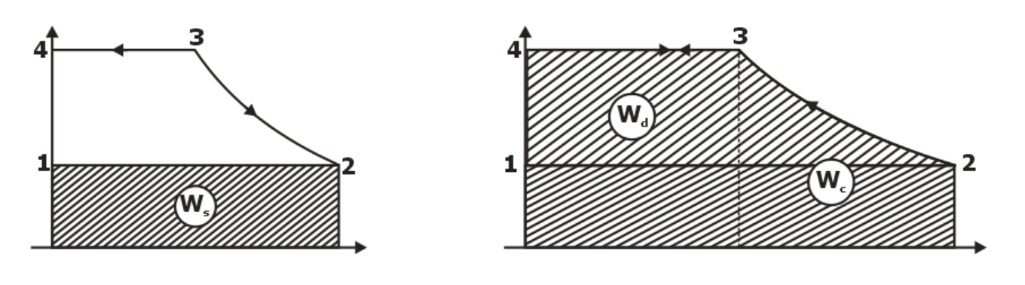





**4.1.2. Compressor work input (with clearance volume)**

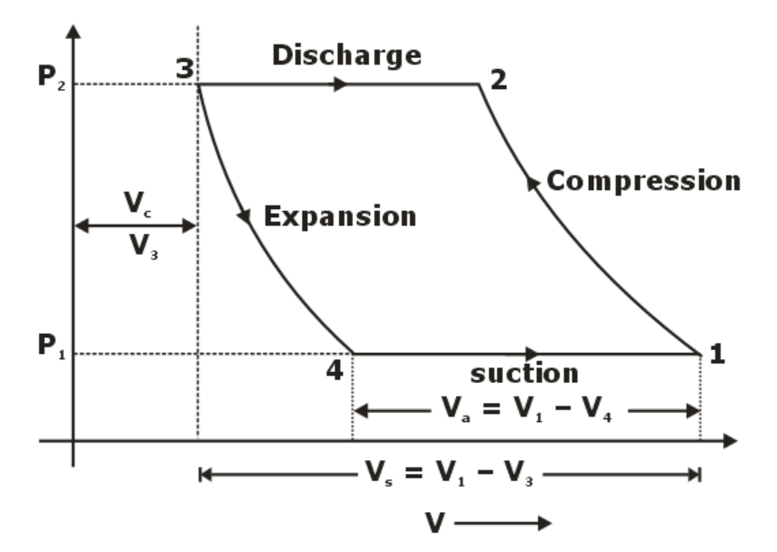



**4.1.3. Volumetric efficiency**





**4.1.4. Multi-stage compression**

* The compression is done with multi-stage with intercooling between stages which results in less total compressor work.
* The optimum pressure ratio per stage in case of n stage compression with intercooling



* The work done in each stage is same.

**5. CENTRIFUGAL COMPRESSOR**

* The principal components of centrifugal compressor are impeller and diffuser.
* Forward curved blade consumes maximum power
* Backward curved blade gives best efficiency and are stable for wide operating range.
* Surging is the complete breakdown of steady flow through compressor, due to periodic flow reversal. This reversal of flow occurs during closing of outlet valve, in operating range having flow rate less than corresponding to maximum pressure ratio. This reversal of flow causes abnormal sound, vibration, decrease in efficiency, increase in temp and if the intensity is more it will lead to mechanical damage.
* The maximum mass flow rate possible through compressor is termed as choking. It occurs when the Mach no. corresponding to relative velocity at inlet become sonic. Choking means fixed mass flow rate irrespective of pressure ratio.

Stalling is an aerodynamic flow separation form the blade surface due to improper design of blade. It is a local phenomenon and chances of flow separation are more at low mass flow rate, non-uniform surface, improper design of blades and higher no. of diffuser blades.