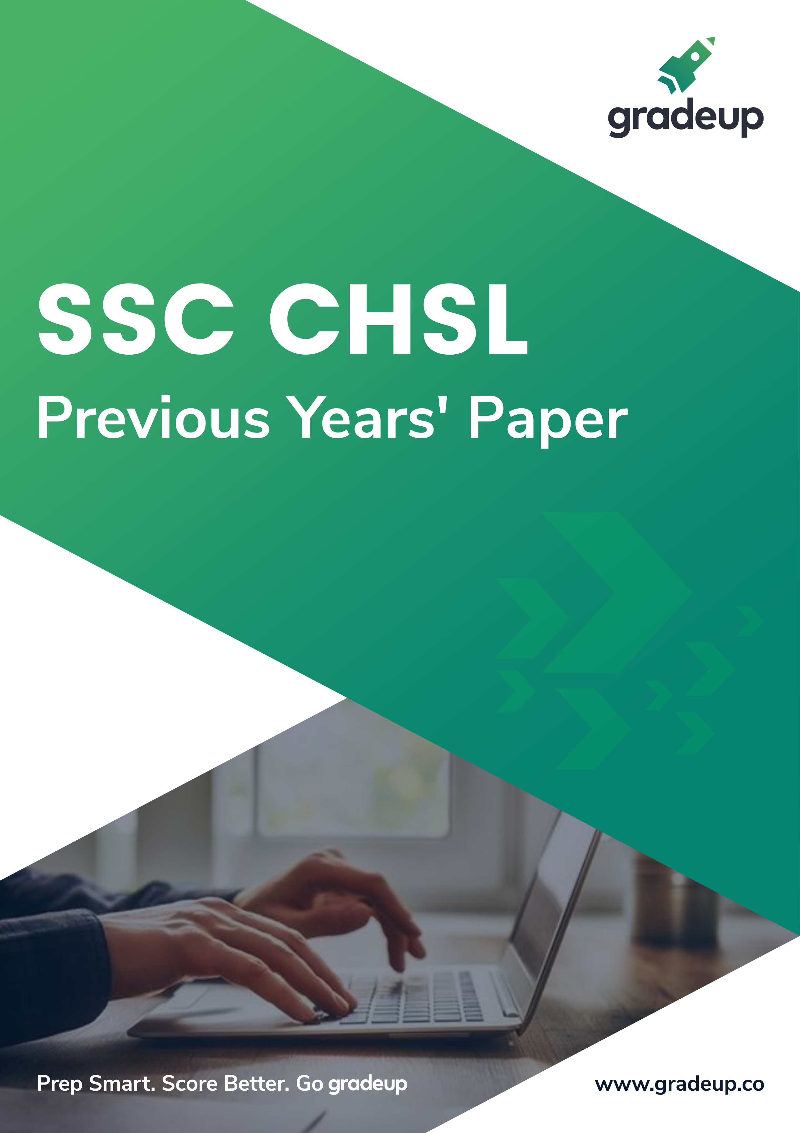

1. In the following question, some part of the sentence may have errors. Find out which part of the sentence has an error and select the appropriate option. If a sentence is free from error, select 'No Error'.
Playing sports and doing any form (1)/ of physical activity can trigger (2)/ the production of endorphins. (3)/ No error (4)
A. 1 B. 2
C. 3 D. 4
Ans. B
2. In the following question, some part of the sentence may have errors. Find out which part of the sentence has an error and select the appropriate option. If a sentence is free from error, select 'No Error'.
During the later 19th and early 20th centuries, (1)/ forest preservation programmes were established (2)/ in British India, the United States, and Europe. (3)/ No error (4)
A. 1 B. 2
C. 3 D. 4
Ans. A
3. In the following question, the sentence given with blank to be ﬁlled in with an appropriate word. Select the correct alternative out of the four and indicate it by selecting the appropriate option.
She was miserable _______ she didn’t tell him.
A. in B. but
C. while D. with
Ans. B
4. In the following question, the sentence given with blank to be ﬁlled in with an appropriate word. Select the correct alternative out of the four and indicate it by selecting the appropriate option.
Despite his pleas, she looked _______ his insincere apologies.
A. on B. to
C. around D. through
Ans. D
5. In the following question, out of the given four alternatives, select the one which best expresses the meaning of the given word.
Cogent
A. Invalid
B. Effective
C. Inconclusive
D. Unlikely
Ans. B
6. In the following question, out of the given four alternatives, select the one which best expresses the meaning of the given word.
Precedence
A. Uprise
B. Insigniﬁcance
C. Present
D. Priority
Ans. D
7. In the following question, out of the given four alternatives, select the one which is opposite in meaning of the given word.
Exorbitant
A. Expensive B. High
C. Cruel D. Modest
Ans. D
8. In the following question, out of the given four alternatives, select the one which is opposite in meaning of the given word.
Gratify
A. Satisfy B. Enchant
C. Disappoint D. Pamper
Ans. C
9. Rearrange the parts of the sentence in correct order.
When the
P : demonstrate that these are wholly inhuman
Q : state identiﬁes some practices
R : as incompatible with the ‘civilised’ norms, it must
A. PQR B. QRP
C. RPQ D. QPR
Ans. B
10. A sentence has been given in Active/Passive Voice. Out of the four given alternatives, select the one which best expresses the same sentence in Passive/Active Voice.
Kiara must deliver the needles.
A. The needles must be delivered with Kiara.
B. The needles must be delivered by Kiara.
C. The needles should deliver by Kiara.
D. The needles are delivered by Kiara.
Ans. B
11. A sentence has been given in Direct/Indirect Speech. Out of the four given alternatives, select the one which best expresses the same sentence in Indirect/Direct Speech.
The principal said, “I want to meet her parents.”
A. The principal wanted to meet her parents.
B. The principal said that he wants to meet her parents.
C. The principal said that he wanted to meet her parents.
D. The principal asked if he could meet her parents.
Ans. B
12. In the following question, a word has been written in four different ways out of which only one is correctly spelt. Select the correctly spelt word.
A. Encouragement
B. Ancouragement
C. Encouragemant
D. Encourragemaent
Ans. A
13. In the following passage, some of the words have been left out. Read the passage carefully and select the correct answer for the given blank out of the four alternatives.
The masses of people accept the most absurd ideas _______ truth, providing they are gravely asserted by some one claiming authority. The most illogical ideas are accepted _______ dispute or examination, providing they are stated solemnly and _______ . Particularly in the respective ﬁelds of religion and politics do we ﬁnd this blind _______ of illogical ideas by the multitude. Mere assertion _______ the leaders seems sufﬁcient for the multitude of followers to acquiesce.
absurd ideas _______ truth, providing
A. as B. like
C. such D. just
Ans. A
14. In the following passage, some of the words have been left out. Read the passage carefully and select the correct answer for the given blank out of the four alternatives.
The masses of people accept the most absurd ideas _______ truth, providing they are gravely asserted by some one claiming authority. The most illogical ideas are accepted _______ dispute or examination, providing they are stated solemnly and _______ Particularly in the respective ﬁelds of religion and politics do we ﬁnd this blind _______ of illogical ideas by the multitude. Mere assertion _______ the leaders seems sufﬁcient for the multitude of followers to acquiesce.
ideas are accepted _______ dispute or examination,
A. within B. not
C. without D. by
Ans. C
15. In the following passage, some of the words have been left out. Read the passage carefully and select the correct answer for the given blank out of the four alternatives.
The masses of people accept the most absurd ideas _______ truth, providing they are gravely asserted by some one claiming authority. The most illogical ideas are accepted _______ dispute or examination, providing they are stated solemnly and _______ Particularly in the respective ﬁelds of religion and politics do we ﬁnd this blind _______ of illogical ideas by the multitude. Mere assertion _______ the leaders seems sufﬁcient for the multitude of followers to acquiesce.
solemnly and _______ _. Particularly in the
A. authoritatively
B. authoritative
C. authority
D. authorities
Ans. A
16. In the following passage, some of the words have been left out. Read the passage carefully and select the correct answer for the given blank out of the four alternatives.
The masses of people accept the most absurd ideas _______ truth, providing they are gravely asserted by some one claiming authority. The most illogical ideas are accepted _______ dispute or examination, providing they are stated solemnly and _______ Particularly in the respective ﬁelds of religion and politics do we ﬁnd this blind _______ of illogical ideas by the multitude. Mere assertion _______ the leaders seems sufﬁcient for the multitude of followers to acquiesce.
ﬁnd this blind _______ of illogical ideas
A. acceptance B. accept
C. acceptor D. acceptant
Ans. A
17. In the following passage, some of the words have been left out. Read the passage carefully and select the correct answer for the given blank out of the four alternatives.
The masses of people accept the most absurd ideas _______ truth, providing they are gravely asserted by some one claiming authority. The most illogical ideas are accepted _______ dispute or examination, providing they are stated solemnly and _______ . Particularly in the respective ﬁelds of religion and politics do we ﬁnd this blind _______ of illogical ideas by the multitude. Mere assertion _______ the leaders seems sufﬁcient for the multitude of followers to acquiesce.
Mere assertion _______ the leaders seems
A. with B. by
C. to D. at
Ans. B
18. In the following question, out of the four alternatives, select the alternative which best expresses the meaning of the idiom/phrase.
Fire the imagination
A. Do something unbelievable.
B. To destroy a person's dreams or ambition by giving discouraging advice.
C. To make someone feel very interested in something and excited about it.
D. Advice someone to be more practical in an effort to tackle a problem.
Ans. C
19. In the following question, out of the four alternatives, select the alternative which best expresses the meaning of the idiom/phrase.
Pulling your leg
A. To create trouble for others.
B. To succeed by making others fail.
C. To trick or lie to someone in a playful way.
D. To beg for a favour.
Ans. C
20. In the following question, out of the four alternatives, select the alternative which is the best substitute of the words/sentence.
A deep cut or tear in skin or flesh
A. Laceration
B. Termination
C. Cessation
D. Desistance
Ans. A
21. In the following question, out of the four alternatives, select the alternative which is the best substitute of the words/sentence.
Barely sufﬁcient or adequate
A. Scant
B. Deluge
C. Plethora
D. Surfeit
Ans. A
22. In the following question, out of the four alternatives, select the alternative which will improve the bracketed part of the sentence. In case no improvement is needed, select "no improvement".
I worry that social media (is killing) creativity.
A. is killed
B. are killed
C. was kills
D. no improvement
Ans. D
23. In the following question, out of the four alternatives, select the alternative which will improve the bracketed part of the sentence. In case no improvement is needed, select "no improvement".
Partition (has been billed) as a distressing phase in the subcontinent’s history.
A. have been billed
B. has being billed
C. has been bill
D. no improvement
Ans. D
24. The question below consists of a set of labelled sentences. Out of the four options given, select the most logical order of the sentences to form a coherent paragraph.
When we use our
A-beauty to group others, we
B-personal standards for
C-promote a kind of apartheid
A. ACB B. BAC
C. ABC D. CBA
Ans. B
25. In the following question, four words are given out of which one word is correctly spelt. Select the correctly spelt word.
A. incommunicabal
B. incommunicable
C. incommunicable
D. incomunicabal
Ans. B

26. In the following question, select the related word pair from the given alternatives.
Tyre : Car : : ? : ?
A. Cart : Tyre
B. Clock : Arc
C. House : Room
D. Chapter : Book
Ans. D
27. In the following question, select the related number pair from the given alternatives.
41 : 123 : : ? : ?
A. 31 : 93 B. 23 : 75
C. 29 : 95 D. 13 : 45
Ans. A
28. In the following question, select the related letter/letters from the given alternatives.
GPQ : ENO : : LNM : ?
A. IKJ B. JLK
C. MON D. OQP
Ans. B
29. In the following question, select the odd word from the given alternatives.
A. Waterfall B. Aquarium
C. River D. Sea
Ans. B
30. In the following question, four number pairs are given. The number on left side of (–) is related to the number on the right side of (–) with some Logic/Rule/Relation. Three are similar on basis of same Logic/Rule/Relation. Select the odd one out from the given options.
A. 62 – 60 B. 74 – 70
C. 18 – 16 D. 34 – 32
Ans. B
31. In the following question, select the odd letter/letters from the given alternatives.
A. VUTS B. RQPO
C. NMKJ D. IHGF
Ans. C
32. From the given alternatives, according to dictionary, which word will come at LAST position?
1. Expiration
2. Expertise
3. Exposing
4. Exposed
5. Explosion
A. Expiration B. Explosion
C. Exposed D. Exposing
Ans. D
33. In the following question, select the missing number from the given series.
91, 73, 164, 237, 401, ?
A. 720 B. 638
C. 432 D. 747
Ans. B
34. A series is given with one term missing. Select the correct alternative from the given ones that will complete the series.
HY, JV, LS, ?, PM
A. MP B. NP
C. MN D. PK
Ans. B
35. The ratio of the present ages of Piyush and Bharat is 11 : 13. 15 years ago, the ratio of ages of Piyush and Bharat was 17 : 21. What is the present age (in years) of Piyush?
A. 66 B. 63
C. 51 D. 78
Ans. A
36. From the given alternatives, select the word which CANNOT be formed using the letters of the given word.
Commissioner
A. Common B. Some
C. Miss D. Trainer
Ans. D
37. In a certain code language, “INDUCE” is written as “MRHYGI”. How is “DEFECT” written in that code language?
A. XGIRIB B. BLKTKC
C. HIJIGX D. RFGAGB
Ans. C
38. In a certain code language, '÷' represents '+', '-' represents 'x', '+' represents '÷' and 'x' represents '-'. Find out the answer to the following question.
9 ÷ 4 - 30 + 10 x 13 = ?
A. 46 B. 8
C. 30 D. 49
Ans. B
39. The following equation is incorrect. Which two signs should be interchanged to correct the equation?
8 - 4 ÷ 25 + 12 x 2 = 1
A. + and x B. ÷ and –
C. + and ÷ D. - and +
Ans. B
40. If 11*8 = 6, 19*7 = 24 and 14*6 = 16, then ﬁnd the value of 12*9 = ?
A. 18 B. 12
C. 8 D. 6
Ans. D
41. Which of the following terms follows the trend of the given list?
ZWXYXYXY, XWZYXYXY, XYZWXYXY, XYXWZYXY, XYXYZWXY,__________.
A. XYXYXYXY
B. ZWXYXYXY
C. XYXYXWZY
D. XWZYXYXY
Ans. C
42. Two taxis T and U start from the same stand. Taxi T travels 1 km South, then turns to its right and travels a further 3.5 km. Meanwhile taxi U travels 2.5 km East, then turns North and travels 4 km, then it turns to its left and travels 6 km. Where is taxi U with respect to taxi T?
A. 3 km North
B. 5 km South
C. 5 km North
D. 3 km South
Ans. C
43. In the question two statements are given, followed by two conclusions, I and II. You have to consider the statements to be true even if it seems to be at variance from commonly known facts. You have to decide which of the given conclusions, if any, follows from the given statements.
Statement I: No plastic are polymers
Statement II: Some rubber are plastic
Conclusion I: Some polymers are rubber
Conclusion II: All rubber are polymers
A. Only conclusion I follows
B. Only conclusion II follows
C. Both conclusions I and II follow
D. Neither conclusion I nor conclusion II follows
Ans. D
44. In the following figure, rectangle represents Event planners, circle represent illustrators, triangle represents Gamers and square represents Indians. Which set of letters represents Event planners who are games?
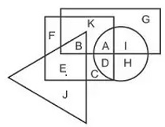
A. BE B. KAB
C. B D. AD
Ans. C
45. A series is given with one term missing. Select the correct alternative from the given ones that will complete the series.
XQC, UNZ, RKW, OHT, ?
A. LFP B. MED
C. LEQ D. MFQ
Ans. C
46. In the following question, select the missing number from the given series.
57, 52, 45, 36, 25, ?
A. 14 B. 12
C. 15 D. 17
Ans. B
47. In the following question, four groups of three numbers are given. In each group the second and third number are related to the ﬁrst number by a Logic/Rule/Relation. Three are similar on basis of same Logic/Rule/Relation. Select the odd one out from the given alternatives.
A. (13, 25, 51) B. (17, 33, 67)
C. (10, 19, 39) D. (7, 13, 29)
Ans. D
48. If a mirror is placed on the line MN, then which of the answer figures is the right image of the given figure?
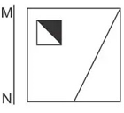
A. 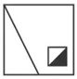 B.

C. D.
Ans. B
49. Which of the following cube in answer figure cannot be made based on the unfolded cube in the question figure?
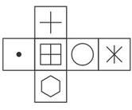
A. B.
C. D.

Ans. D
50. A word is represented by only one set of numbers as given in any one of the alternatives. The sets of number given in the alternatives are represented by two classes of alphabets as shown in the given two matrices, The columns and rows of Matrix-I are number from 0 to 4 and that of Matrix-II are numbered from 5 to 9. A letter from these matrices can be represented first by its row and next by its column, for example ‘D’ can be represented by 24, 41 etc and ‘T’ can be represented by 96, 87 etc. Similarly, you have to identify the set for the word ‘GASH’.

Matrix-I
आव्यूह -I
 | 0 | 1 | 2 | 3 | 4
0 | C | G | D | K | M
1 | I | B | L | H | B
2 | K | B | L | B | D
3 | I | A | C | D | E
4 | L | D | G | A | E

Matrix-II
आव्यूह -II
 | 5 | 6 | 7 | 8 | 9
5 | P | Q | U | W | R
6 | P | Z | V | P | W
7 | U | X | Q | X | V
8 | V | O | T | N | R
9 | P | T | U | S | Y

A. 23,75,44,88
B. 42,43,98,13
C. 14,95,13,58
D. 11,78,20,87
Ans. B

51. The value of is _______.
A. B.
C. D.
Ans. B
52. If doubling a number and adding 16 to the result gives the same number as multiplying the number by 6 and taking away 4 from the product, then ﬁnd the number.
A. 4 B. 5
C. 6 D. 7
Ans. B
53. If then find the value of ‘x’.
A. 1 B. 2
C. 3 D. 4
Ans. D
54. If , then find the value of .
A. 9 B. 19
C. 38 D. 42
Ans. B
55. If the supplement of an angle is (5/2) of its complement, then ﬁnd the angle.
A. 10° B. 15°
C. 20° D. 30°
Ans. D
56. If the sides of a triangle are in the ratio 9:6:4, then the triangle is said to be_________.
A. right angled
B. obtuse angled
C. acute angled
D. All are incorrect
Ans. B
57. Puneet scored 10% marks in an exam and failed by 50 marks. If he scored 40% marks, then he gets 25 marks more than passing marks. What is the passing marks for the exam?
A. 250 B. 200
C. 150 D. 75
Ans. D
58. A bag contains 10 rupees, 2 rupees and 1 rupee coins. The value of 10 rupees, 2 rupees and 1 rupee coins are in the ratio of 15 : 8 : 1 respectively. If total number of coins is 273, then what will be the total value (in Rs) of all coins?
A. 1008 B. 924
C. 1102 D. 1218
Ans. A
59. Vipin adds 3 litres of liquid A in 6 litres of liquid B and Mohit adds 8 litres of liquid A in 15 litres of liquid B. What is the ratio of the percentage of liquid B in the two mixtures?
A. 26 : 25 B. 51 : 32
C. 46 : 45 D. 34 : 25
Ans. C
60. Average of 9 consecutive natural numbers is 41. What is the largest among these numbers?
A. 37 B. 44
C. 46 D. 45
Ans. D
61. At the rate of 12.5% per annum, the simple interest on a sum is 5/4 of the principal. What is the time period (in years)?
A. 12.5 B. 8
C. 10 D. 15
Ans. C
62. If the cost price of a table is 62% of the selling price, then what is the proﬁt percentage?
A. 43.42 B. 37.45
C. 61.29 D. 71.35
Ans. C
63. The marked price of a trouser is Rs 3510. The shopkeeper allows a discount of 40% and gains 17%. If no discount is allowed, then what will be the proﬁt percentage?
A. 63.8 B. 95
C. 85 D. 74.6
Ans. B
64. What is the value of ?
A. 1.75 B. 1.25
C. 1.6 D. 1.5
Ans. A
65. M takes 60% more time than N to complete a wall. If together they complete the wall in 24 days, then how many days will N alone take to complete it?
A. 36 B. 39
C. 42 D. 34
Ans. B
66. A boy is driving car at the speed of 42 km/hr. He stops for 8 minutes at end of every 11 km. What will be the time (in minutes) taken by him to cover a distance of 84 km?
A. 138 B. 142
C. 156 D. 176
Ans. D
67. The line graph shows the average hours per day spent by teenagers watching TV. Study the diagram and answer the following questions.
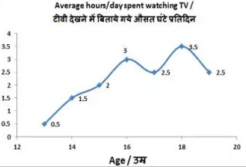
In which age do teenagers spend the least number of hours watching TV?
A. 17 B. 15
C. 13 D. 18
Ans. C
68. The line graph shows the average hours per day spent by teenagers watching TV. Study the diagram and answer the following questions.

What is the ratio of hours per day spent in watching TV by 14 year olds and 18 year olds?
A. 7 : 3 B. 3 : 7
C. 5 : 7 D. 7 : 5
Ans. B
69. The line graph shows the average hours per day spent by teenagers watching TV. Study the diagram and answer the following questions.
The number of hours per day spent in watching TV is_________more by 17 year olds as compared to 15 year olds.
A. 25% B. 20%
C. 16.7% D. 30%
Ans. A
70. The line graph shows the average hours per day spent by teenagers watching TV. Study the diagram and answer the following questions.
How many hours does a 16 year old spend watching TV in a week?
A. 25.5 B. 25
C. 21 D. 22.5
Ans. C
71. The area of an equilateral triangle is 9√3 cm². Find its side (in cm).
A. 3 B. 6
C. 12 D. 18
Ans. B
72. The area of a circle is 38.5 cm². Find its diameter (in cm).
A. 7 B. 14
C. 10 D. 20
Ans. A
73. Find the total surface area (in cm²) of a hemisphere of diameter 7 cm.
A. 105.5 B. 99
C. 77 D. 115.5
Ans. D
74. ΔXYZ is right angled at Y. If m∠Z = 30°, then ﬁnd the value of (cosX - 1/√3).
A. 3/2 B. 1-√2
C. (4-√3)/2√3 D. (√3-2)/2√3
Ans. D
75. In ΔABC measure of angle B is 90°. If sinA = 15/17, and AB = 0.8cm, then what is the length (in cm) of side BC?
A. 1.5 B. 1.7
C. 2 D. 2.5
Ans. A

76. Participatory Notes (PNs) are associated with which one of the following?
A. Consolidated Fund of India
B. Foreign Institutional Investors
C. United Nations Development Programme
D. Unemployment Related Index
Ans. B
77. In which of the following years was the Food Corporation of India (FCI) set up?
A. 1955 B. 1960
C. 1965 D. 1970
Ans. C
78. The word monsoon refers to_________.
A. blowing of wind in one direction always
B. blowing of wind swiftly
C. blowing of wind slowly
D. Changing direction of winds
Ans. D
79. Which of the following cities is NOT situated on the bank of river Ganga?
A. Kanpur B. Patna
C. Varanasi D. Lucknow
Ans. D
80. Which of the following Harappan sites used mud-bricks in ample for the construction of houses?
A. Mohenjodaro B. Harappa
C. Kalibanga D. Chanhudaro
Ans. B
81. Which of the following newspapers is NOT related to Madan Mohan Malaviya?
A. Leader B. Comrade
C. Hindustan D. Abhyudaya
Ans. B
82. Who is considered the real founder of Jainism?
A. Parshwanath
B. Rishabhdev
C. Neminath
D. Arishtanemi
Ans. B
83. The 7th International Ground Water Conference was hosted by which country from December 11-13, 2017?
A. China B. India
C. South Africa D. Australia
Ans. B
84. Which ﬁlm was awarded the best ﬁlm in the international ﬁlm competition category at the 23rd Kolkata International Film Festival (KIFF) that concluded in November 2017?
A. Los Perros
B. Swan
C. Kupal
D. Birds are singing in Kigali
Ans. A
85. In which year Pakistan became a federal republic?
A. 1948 B. 1956
C. 1971 D. 1975
Ans. B
86. Which of the following element has highest electronegativity?
A. Fluorine B. Sodium
C. Chlorine D. Oxygen
Ans. A
87. Bohr’s model is related to which of the following?
A. Plum pudding model
B. Nuclear theory
C. Concept of quantization of energy
D. Dual nature of electron
Ans. C
88. Which among the following comes under Union List of Indian Constitution?
I. Defence
II. Inter-state Trade and Commerce
III. Banking
A. Only I
B. Only II
C. Both I and II
D. All I, II and III
Ans. D
89. In India, Financial Emergency can be extended for how much maximum duration?
A. Six months
B. Nine months
C. Two years
D. Indeﬁnite period
Ans. D
90. The process in which the organism can be cut into any number of pieces and each piece grows into a complete organism is called_________.
A. Regeneration
B. Budding
C. Spore formation
D. No option is correct.
Ans. A
91. Which meristem increases the length of the stems and the roots?
A. Apical meristem
B. Lateral meristem
C. Intercalary meristem
D. Nodal meristem
Ans. A
92. In December 2017, the scheme named ‘PMVVY’ was launched. It aims to provide social security during old age. What is the limit of maximum purchase price under this scheme?
A. Rs 5,00,000
B. Rs 7,50,000
C. Rs 10,50,000
D. Rs 12,50,000
Ans. B
93. Which type of battery is used in world’s ﬁrst fully electric cargo ship launched by China?
A. Zinc-carbon battery
B. Lithium-ion battery
C. Zinc-air battery
D. Lead-acid battery
Ans. B
94. In January 2018, Atal Pension Yojana (APY) crossed 80 lakh subscribers. What is the maximum amount of monthly pension the beneﬁciary can get under APY?
A. Rs 4000 B. Rs 5000
C. Rs 10,000 D. Rs 15,000
Ans. B
95. On 27 January 2018, the Ministry of Electronics and Information Technology launched which initiative for Women Health and Hygiene?
A. Stree Swabhiman
B. Mahila Swabhiman
C. Nari Swabhiman
D. Nari Shakti
Ans. A
96. Calculate the time period (in seconds) of a sound wave of wavelength 3 m travelling with a speed of 300 m/s.
A. 900 B. 0.02
C. 450 D. 0.01
Ans. D
97. Sound is produced by_________objects.
A. perpetual B. uniform
C. stable D. vibrating
Ans. D
98. _________constitute the biotic component of the biosphere.
A. Non-living and Living things
B. Living things
C. Minerals
D. Atmosphere
Ans. B
99. Which of the statements given below are correct?
A) France hosted the 2017 World Team Chess Championship.
B) In 2017 Pro Kabaddi League, Amit Hooda played for Bengal Warriors.
C) In 2017, LeBron James played for the NBA team New Orleans Pelicans.
A. Only B
B. Only C
C. Both A and B
D. No option is correct
Ans. D
100. In HTML,_________pair deﬁnes a cell and number of such pairs you use will deﬁne the number of cells your row is divided into.
A. <table></table>
B. <tr></tr>
C. <td></td>
D. <th></th>
Ans. C

